SOFTWARE DEVELOPMENT LIFECYCLE:

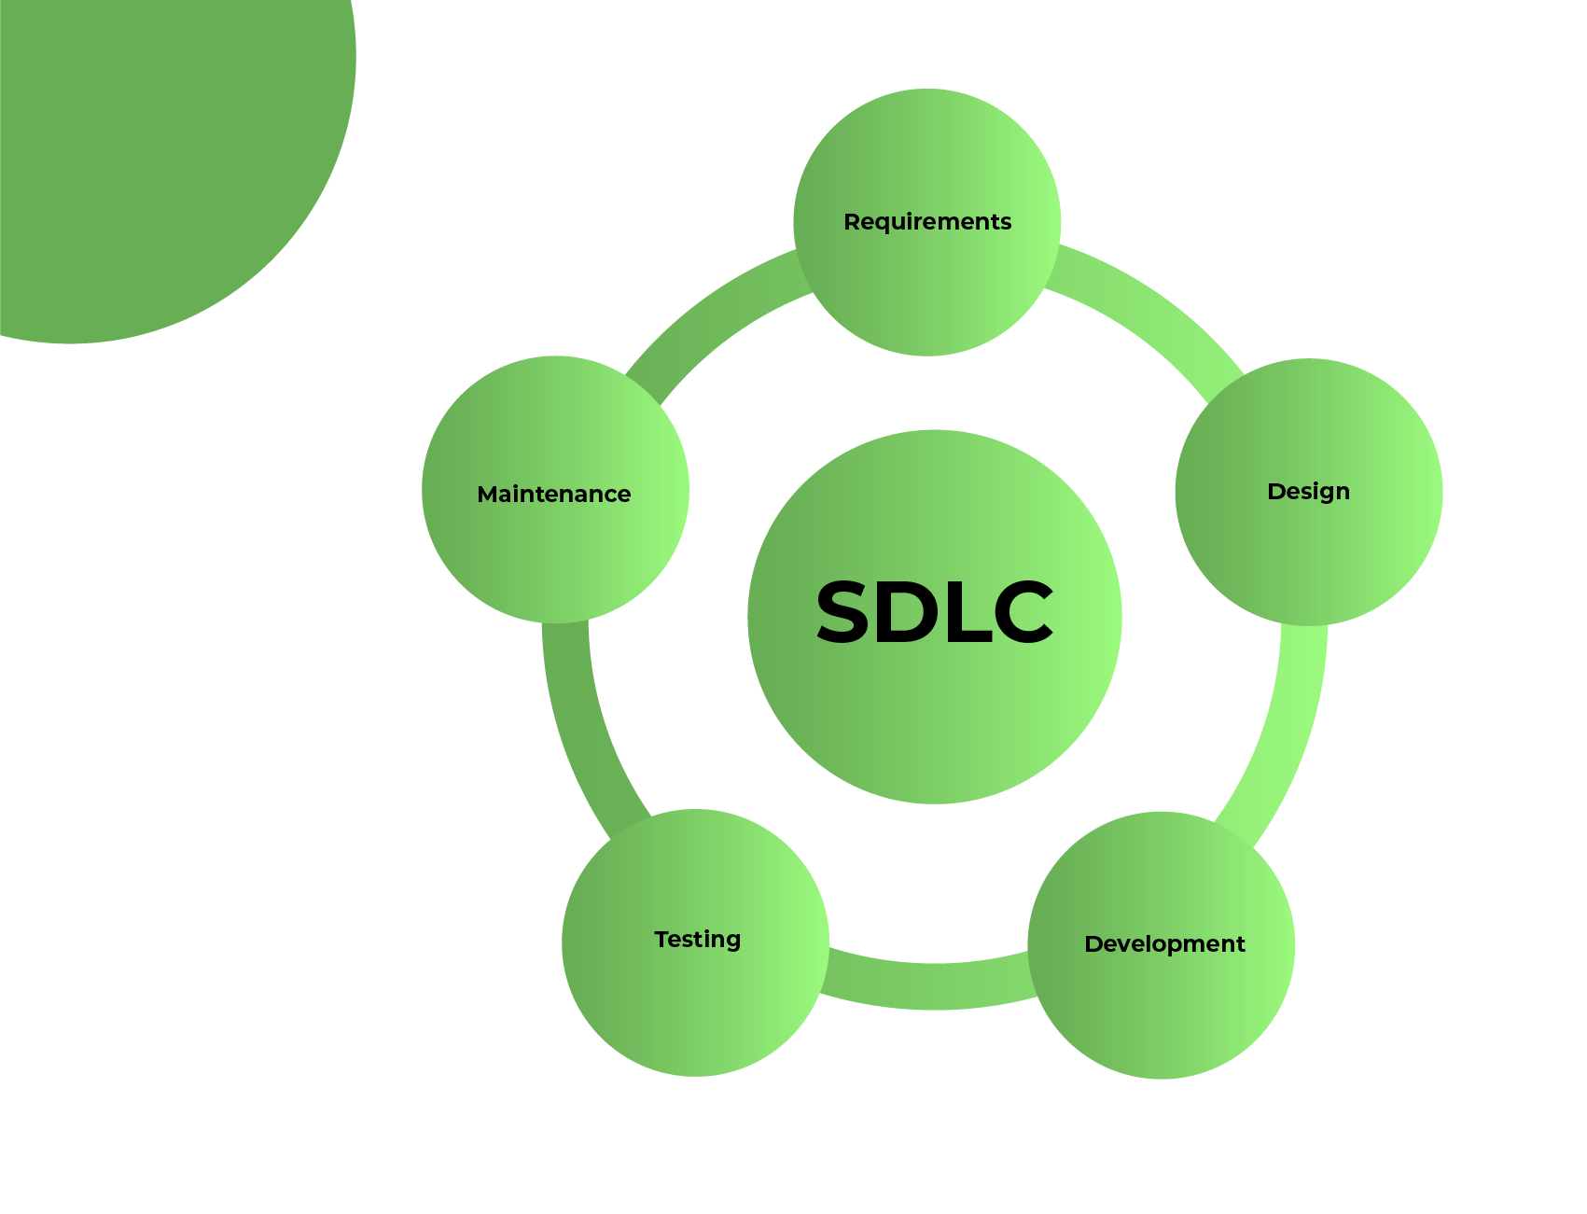

**SDLC Phases:**

**1. Requirements Gathering:**

Understanding client needs and project scope.

Essential for aligning development goals with business objectives.

Sets the foundation for the entire project.

**2. Design:**

Planning the architecture and framework of the software.

Translating requirements into technical specifications.

Crucial for ensuring scalability, efficiency, and maintainability.

**3. Implementation:**

Writing code according to design specifications.

Bringing the software to life through programming.

Requires attention to detail and adherence to coding standards.

**4. Testing:**

Evaluating the software to identify defects and ensure functionality.

Includes unit testing, integration testing, and system testing.

Essential for delivering a reliable and high-quality product.

**5. Deployment:**

Releasing the software to users or clients.

Involves installation, configuration, and rollout.

Marks the culmination of development efforts and transition to production.

**Interconnection of Phases:**

Requirements inform design, which guides implementation.

Testing validates the functionality and quality of implemented code.

Deployment showcases the end result of the development process.

Each phase builds upon the previous one, ensuring a smooth progression through the SDLC.

***Importance of Each Phase:***

Requirements: Defines project scope and objectives.

Design: Establishes the blueprint for development.

Implementation: Turns design into functioning code.

Testing: Identifies and rectifies defects to ensure quality.

Deployment: Delivers the final product to users for utilization.